



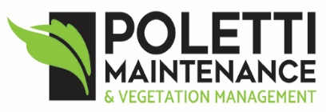




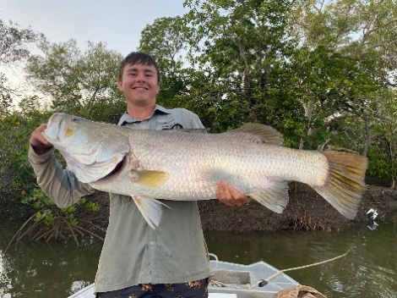
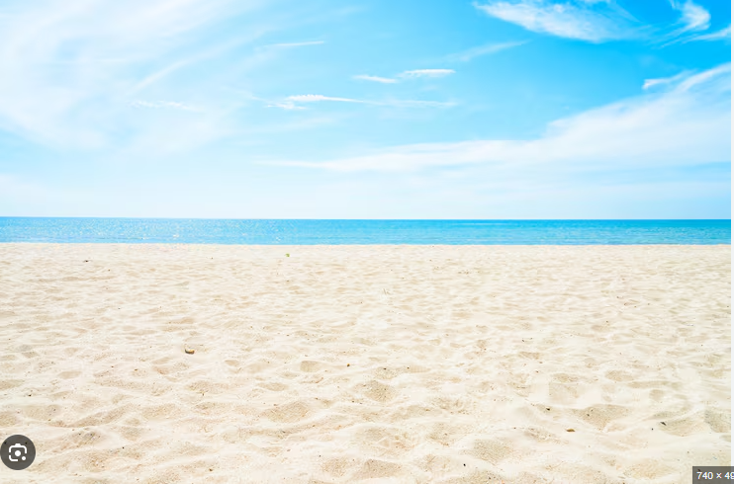
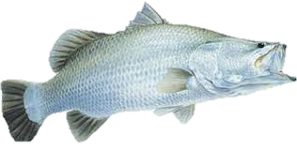
ADDITIONAL INFORMATION
- Brag mat photo entries only are accepted. Fish size accepted is 58cms to 120cms.
- The club will make use of the “Track My Fish” app. You will need to install it and search for our competition. Your brag mat photos can be uploaded to the app.
- The app only accepts fish caught in the geographic footprint and the time frame that we supply. The geographic footprint covers the saltwater reaches of Salmon and Bomber Creek as well as Morris’ (Barramundi) Creek and the Haughton River.
- An individual fisherperson can only win one prize but can submit more than one fish.
- All decisions will be made by the Event Organiser (Dennis McCloskey) and the Club’s Fishing Coordinator (Michael Martini) and will be final and binding.
- The Cungulla Fishing Club’s dedicated phone number is 0492 279 103

$2600 TOTAL PRIZE MONEY
Longest Fish - $800
Aggregate Length - $500
Secret Length - $500
Longest Fish - Juniors 15 years and under - $400
Random Draws x 4 - $100

2026

Fishing commences on Saturday 3 October at 6am
Fishing concludes on Sunday 4 October at 4pm
Results and prize presentations are at Cungulla Community Hall at 4pm

ENTRY FEES AND REGISTRATION
Download the “Cungulla Barra Competition Event Registration” document from the Cungulla Fishing Club website and follow the directions
Non-Members $30 per person, all ages
Members $20 per person, all ages

BARRAMUNDI TOURNAMENT

CLUB
CUNGULLA FISHING

